Cryptography – Case Study Report
CYBR3030
Identity Management

Arr Domingo
Student ID: 200458099
December 2025

Instructor: Sam El-Awour
Table of Contents
1 Summary 1
2 Network Diagram 1
3 Gap Analysis and Associated Risks 3
3.1 Danger in storing plaintext credentials 3
3.2 Use of self-signed certificate in data transit 3
3.3 Lack of security for data at rest 3
3.4 Unsecured authorized partner access 4
3.5 Insufficient network segmentation 4
4 Recommendations and Justifications 4
4.1 Danger in storing plaintext credentials 4
4.2 Use of self-signed certificate in data transit 4
4.3 Lack of security for data at rest 5
4.4 Unsecured authorized partner access 5
4.5 Insufficient network segmentation 5
References 1

1 Summary
Due to the sensitive nature of this project, having strong data protection is essential. By implementing cryptography, it enables confidentiality by preventing unauthorized access and protects critical information from being exposed. It protects the integrity of data by making sure it is not altered or otherwise tampered during the transmission within the Edmonton Main Office and the authorized partners. It also guarantees authenticity by ensuring that users or authorized partners are who they claim to be.
Therefore, this report identifies several security gaps, including the danger in plaintext credentials storage, usage of a self-signed certificate in data transit, lack of security for data at rest, unprotected authorized partner access, and insufficient network segmentation. Moreover, this report provides recommendations for modern cryptographic controls. These protections include the use of bcrypt/Argon2 hashing instead of plaintext in storing important credentials, replacing self-signed certificate with a trusted CA-signed certificate for the data transit, use AES-256 for databases and file storage, issue unique API tokens as well as implementing RBAC for authorized partners, and add demilitarized zone on the network layout. These changes will significantly enhance data confidentiality, integrity, authenticity, and system resilience.

2 Network Diagram
This is the current network diagram of Edmonton Comics main office which consists of a firewall, load balancer, 3 web servers, and 2 database servers. The firewall is used to protect the network and allow authorized traffic. The network traffic on the web servers is managed by load balancer, and the database servers are clustered for redundancy and fault tolerance purposes.
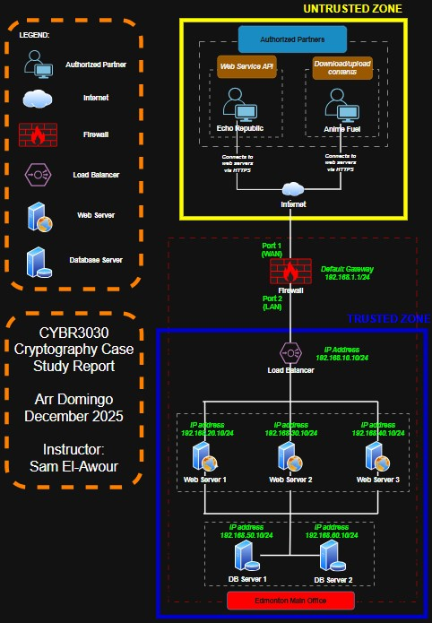
Network Diagram of Edmonton Comics main office.

3 Gap Analysis and Associated Risks
This section is the evaluation of Edmonton Comics’ current state with the authorized partners to identify the weaknesses or potential risks. This way, a roadmap for improvement will be developed to achieve the general goal of the company. Overall, the desired state would be to safeguard the valuable data of the company.

3.1 Danger in storing plaintext credentials
Current State: Both usernames and passwords on web servers are stored in plaintext form.
Risk: There is a high likelihood of credential theft if servers are compromised. Attackers could gain full unauthorized access.

3.2 Use of self-signed certificate in data transit
Current State: Web servers use a self-signed TLS certificate.
Risk: Partners cannot validate server authenticity, increasing chance of man-in-the-middle attacks.

3.3 Lack of security for data at rest
Current State: Sensitive project files and database content are not encrypted.
Risk: If attackers access storage, sensitive comics and business data could be exposed.

3.4 Unsecured authorized partner access
Current State: The company wants to share and store data securely, however Echo Republic and Anime Fuel rely on web-based access without enforced cryptographic standards.
Risk: Web service API and file transfer increase potential unauthorized access.

3.5 Insufficient network segmentation
Current State: Web servers and databases appear to be closely linked without additional isolation.
Risk: Increases lateral movement risk by attackers making it easier for them to move from a single compromised device to other parts of the network and causes a widespread breach.

4 Recommendations and Justifications

4.1 Danger in storing plaintext credentials
The recommended security steps is to migrate from plaintext to bcrypt/Argon2 hashing.
Explain here

4.2 Use of self-signed certificate in data transit
It is recommended to replace self-signed certificate to CA-signed certificate. This helps provide trusted authentication for partners and essential for secure API and file transfer.

4.3 Lack of security for data at rest
It is highly recommended to use AES-256 for databases and file storage.

4.4 Unsecured authorized partner access
The recommendation here is to issue unique API tokens per partner and implement RBAC to control what each partner can access.

4.5 Insufficient network segmentation
The recommendation is to include an additional protection from untrusted traffic by implementing the demilitarized (DMZ) zone that would separate partner zone and trusted zone.

References

Why cryptography is important and how it’s continually evolving. (2024, December 23). Retrieved from Sectigo: https://www.sectigo.com/blog/cryptography-importance-how-its-changing

